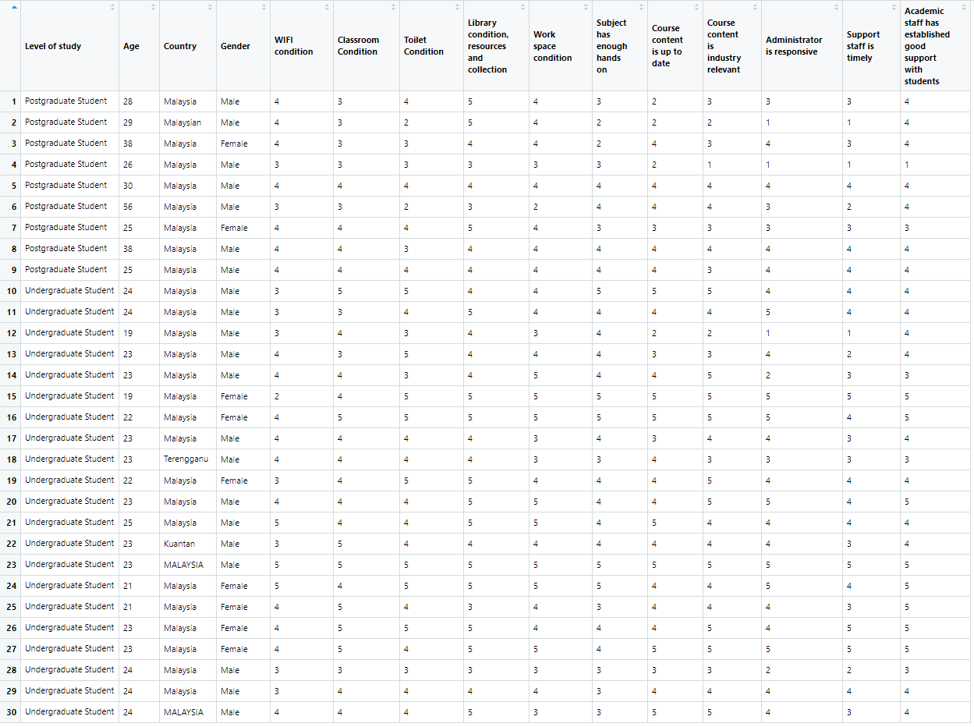

Figure 1: the table that has eliminated timestamp column

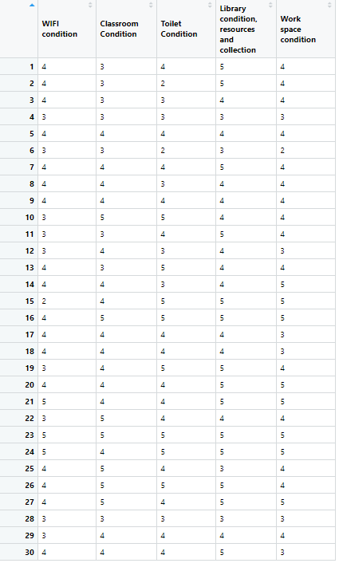

Figure2:Part A

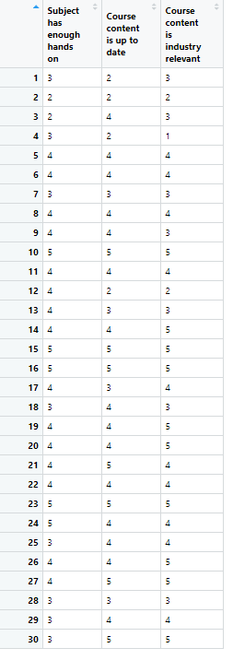

Figure3: partB

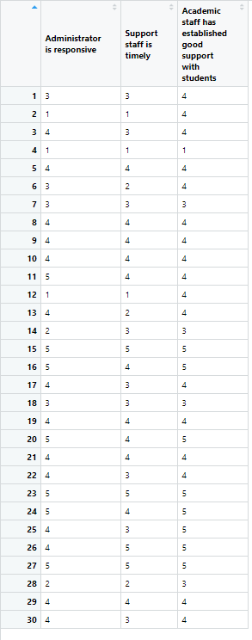

Figure 4: partC

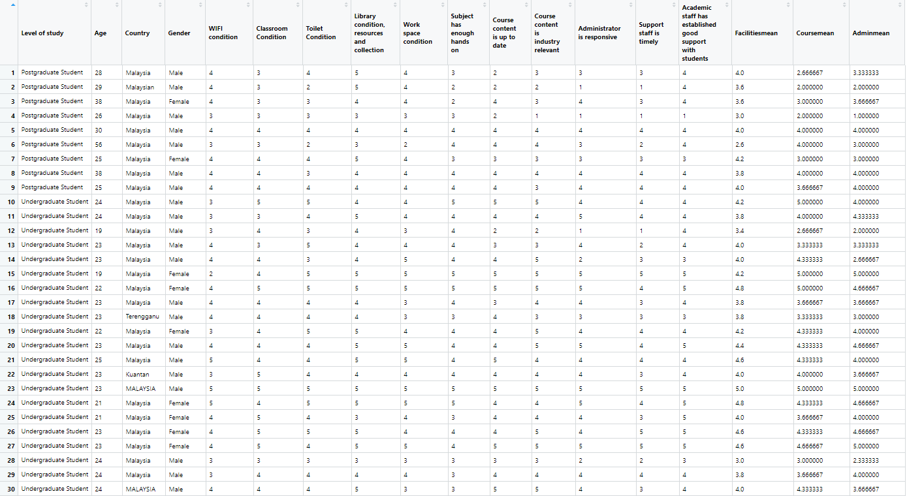

Figure 5:Overall table for inserting mean of partA, partB and partC

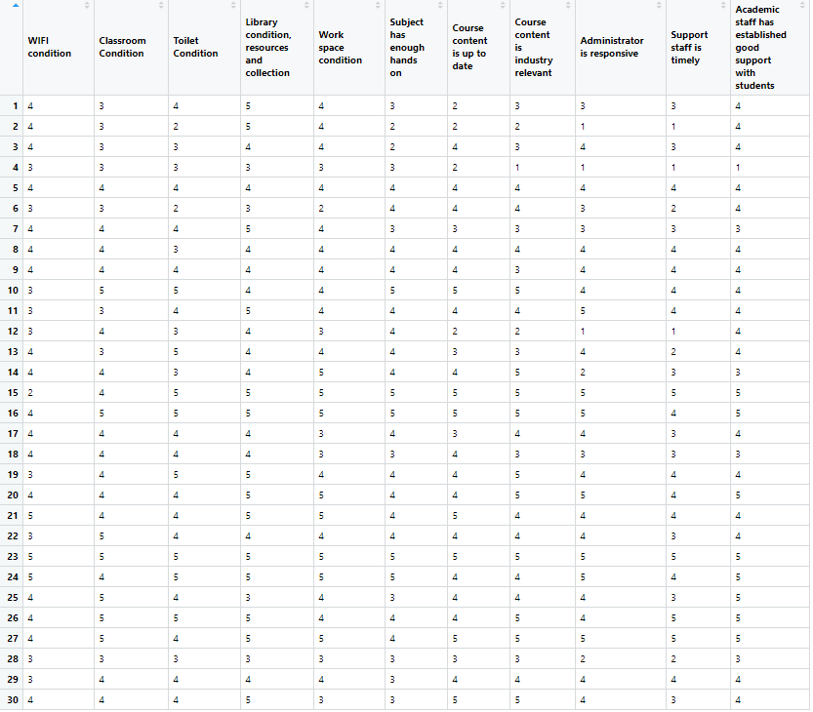

Figure 6: Calculating mean of each column inside KICT satisfaction level table

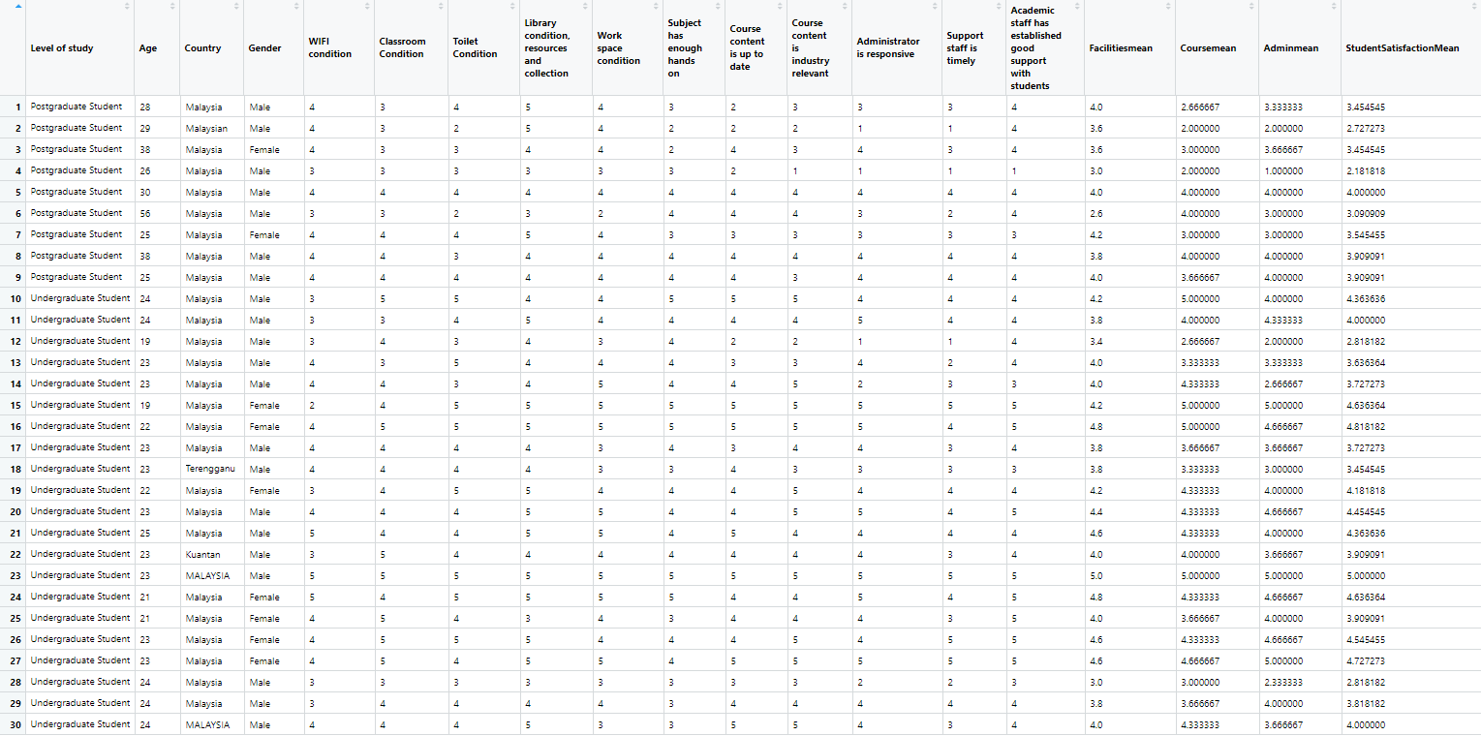

Figure 7: The overall table after inserting studentsatisfactionmean

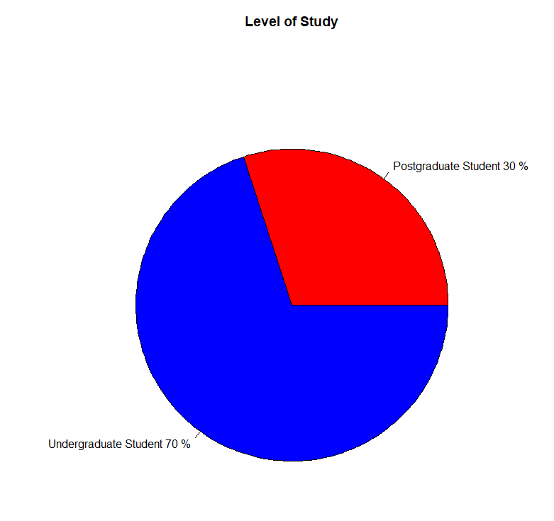

Figure 8 : Pie chart for level of study

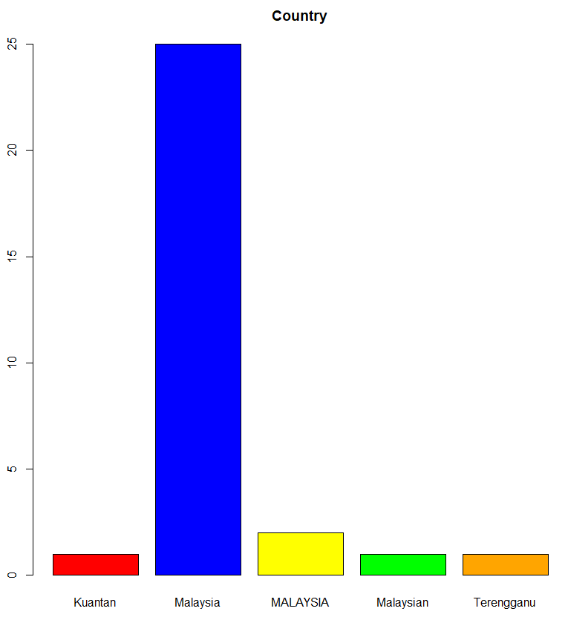

Figure 9: Bar chart of country of the respondent comes from

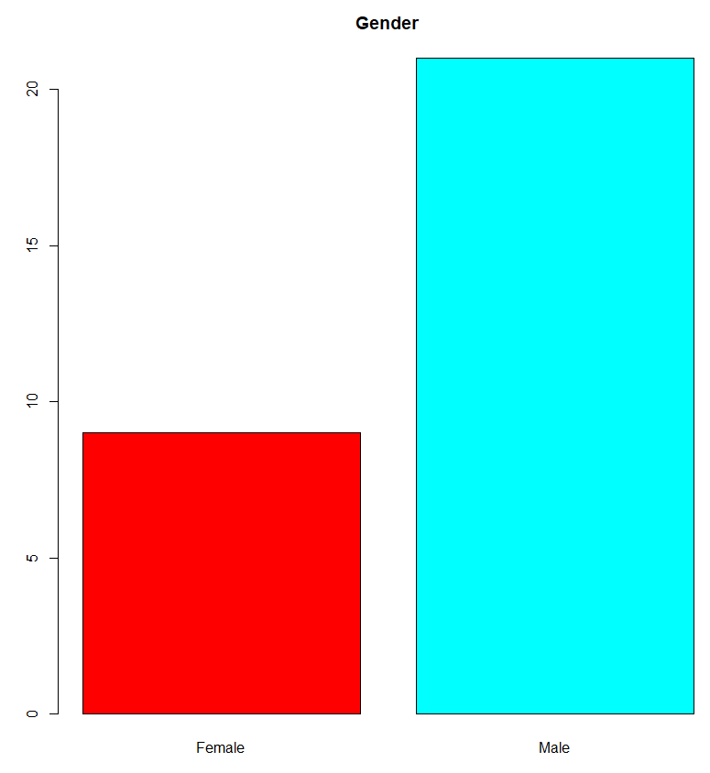

Figure 10: Gender

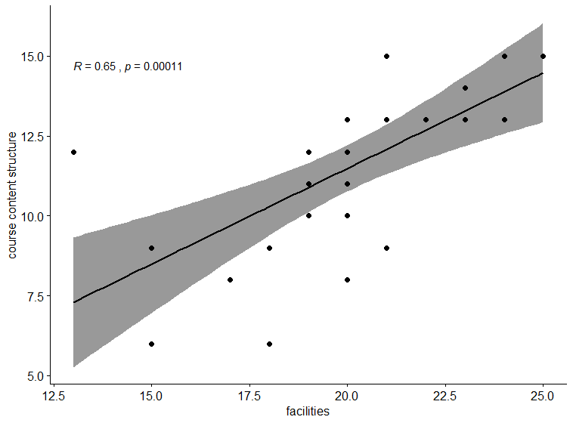

Figure 11: cor test main determinants and the students satisfaction

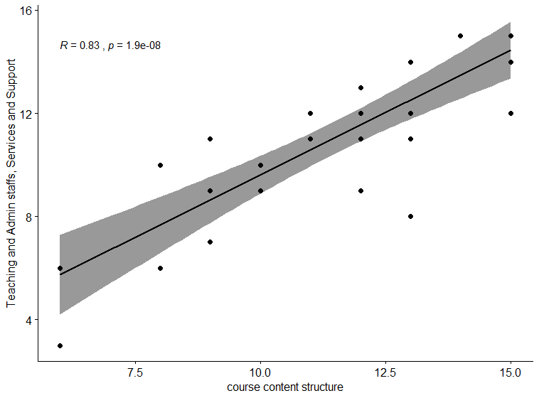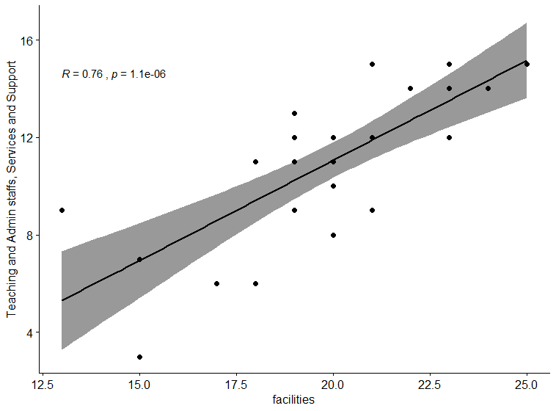

Figure 12: cor test between determinants